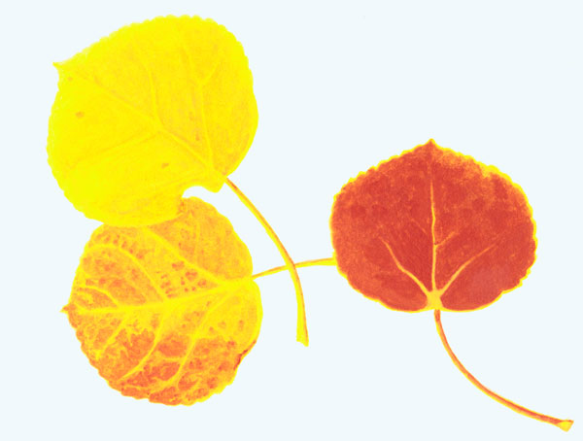25th Annual
Aspenfest Invitational
Levels 2-5
Excel All Levels

Date: Saturday and Sunday
November 4th and 5th

Location: Ruidoso Gymnastics
PO Box 1589
Ruidoso Downs, NM 88346
(575) 378-4468

Entry Fee: $65.00 compulsory / $40.00 excel

Deadline: Entry and ALL MONEY due by Friday,
October 6th. All entries postmarked after
October 6th will be charged a $5.00 late fee
Per gymnast, provided space is available.

Times: Sessions and times will be announced upon receipt
Of entries.

Judges: 2 judges per event

Awards: Levels 2, 3, 4, and excel: Achievement Awards for events and placement awards for all-around.
Level 5: Event awards will vary depending on the
Number of competitors.
All athletes will receive all-around awards.
Hand-carved bears for first-third individual all-around (levels 2 – 5) and first and second place team.

Host Hotel: Best Western Pine Springs Inn, $54.99 plus tax for standard room with two queen beds. Mention gymnastics meet
When making reservations. (575) 378-8100

